A l p h a l i z e T e c h n o l o g i e s

369 Attendance

HR Guide
Decide leave, cancellations and work from home, and see who is in today.

About This Guide
This is the guide for the people who approve requests in 369 Attendance, from Alphalize Technologies: leave, cancellations of leave that is already approved, and work-from-home days. It covers the HR tab, the middle tab along the bottom of the screen, and everything you can reach from it.
You get the HR tab when your administrator has given you at least one approval permission (Leave Manager, WFH Manager, HR Officer or HR Manager) but not full settings access. Administrators see a Config tab in the same place instead, and staff with none of these permissions see only Home and Profile.
It describes the app exactly as it behaves on the phone. Every button name, field label and message in this guide is quoted from the app itself, so what you read here is what you will see on the screen.
Your own day works exactly as it does for everyone else. Checking in and out, applying for leave and asking to work from home are in the Employee Guide. Office hours, public holidays, the leave policy, auto-approval and payroll are set by your administrator and are in the Administrator Guide; none of them can be reached from the HR tab.
TIP Your HR page may not show every section in this guide. Each section appears only when your login holds the matching permission, and a missing section does not grey out. It is simply not there. Nothing is broken; ask your administrator.

369 Attendance at a Glance
▪ Start of the day — open HR and look for red numbers beside Leave requests, Cancellation requests and Work from home requests.
▪ Through the day — open each waiting request, read the figures, and Approve or Reject it.
▪ When someone changes their mind — decide their request with Approve cancellation or Keep leave.
▪ Any time — tap Present, Late, On leave or Absent under TODAY to see who is where.
▪ Before you finish — pull the HR page down to refresh it and check that nothing is still waiting.

PART 1 YOUR HR PAGE

Step 1 Find the HR Tab
Sign in as usual. Along the bottom of the screen sit three tabs: Home, HR and Profile. The tab you are on is filled in amber.
The HR tab can take a moment to appear after you sign in. The app asks the server what your login is allowed to do and adds the tab once the answer arrives. It asks each time you sign in or open the app, so if your administrator changes your permissions, sign out and back in to see the change.
Home is your own day: your check-in card, your month, and the shortcuts to your own leave and work from home. Profile is your own details. Both work the same for you as for any employee.
What you tap | What happens
Home | Your own attendance, exactly as every employee sees it
HR | Today's attendance and the requests waiting for you
Profile | Your own details

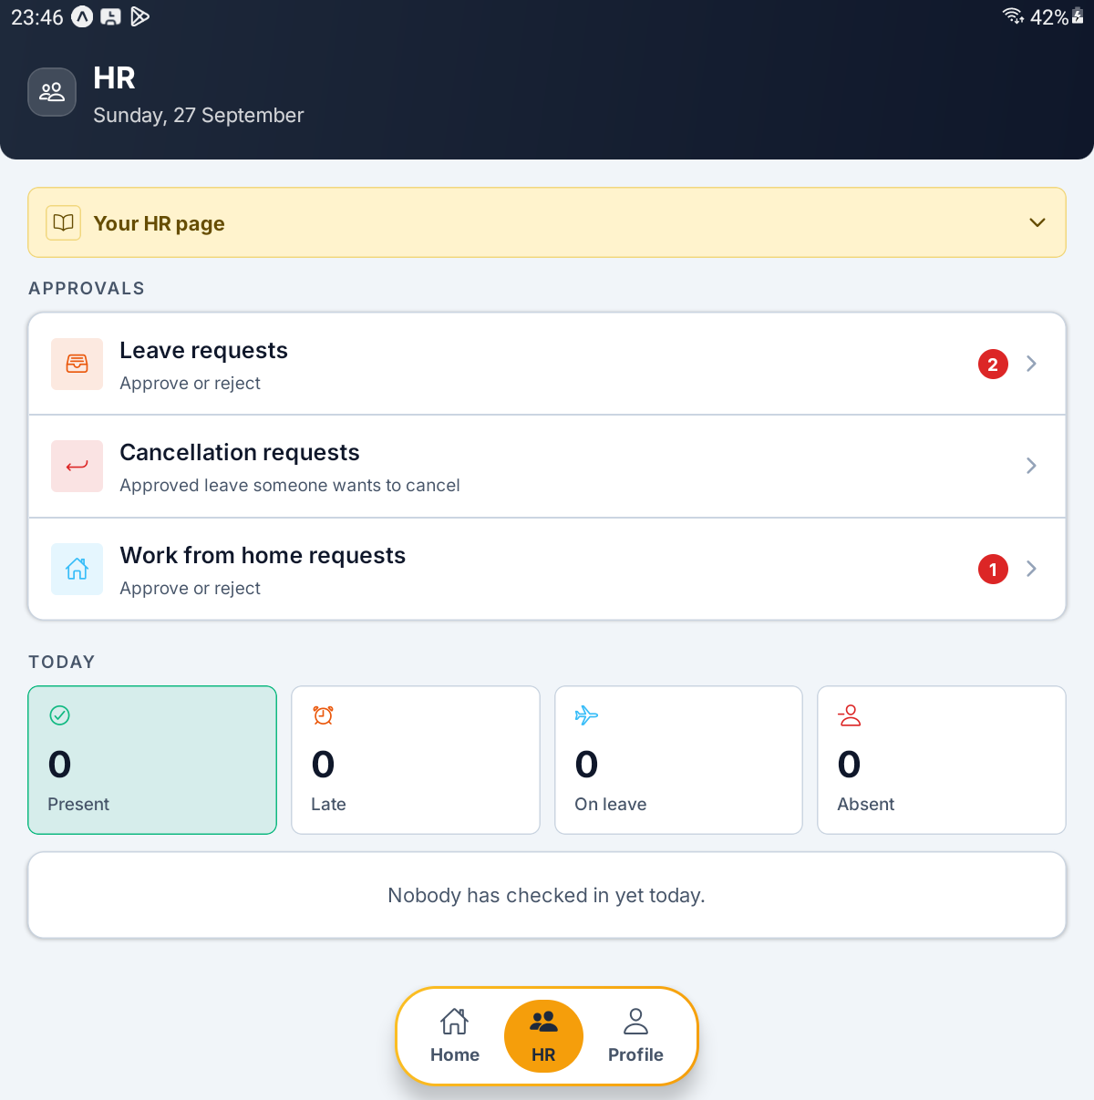
The HR page — the Your HR page guide, the APPROVALS rows with their red counts, and the TODAY boxes

Step 2 Read the HR Page
The header reads HR with today's date beneath it. Below it is a yellow box headed Your HR page. It starts folded; tap it to open four short reminders, and tap it again to fold it away.
Under the box are two sections. APPROVALS has one row for each queue you can decide. TODAY shows who is in.
A red number on a row is how many requests are waiting in that queue. When nothing is waiting there is no number at all, so a row without one simply means there is nothing to do.
Pull the page down to refresh it. It also refreshes by itself every time you come back to it, so a request you have just decided has already left the count on your way back.
What you see | What it means
Leave requests — Approve or reject | Leave waiting for its first decision
Cancellation requests — Approved leave someone wants to cancel | Approved leave the employee has asked HR to cancel
Work from home requests — Approve or reject | Work-from-home days waiting for a decision
Red number | How many are waiting in that queue

[ IMAGE 2 — not captured yet ]
The Your HR page guide opened, showing its four reminders

Step 3 Know Why a Section Is Missing
The HR page is built from your permissions, and each part is checked on its own. Leave rights and work-from-home rights are two separate permissions: holding one does not give you the other.
Your administrator has given you | You see
Leave Manager | Leave requests and Cancellation requests
WFH Manager | Work from home requests
HR Officer or HR Manager | TODAY and its four boxes

If the page shows only Checking what you can see…, the app is still waiting for the server to answer, or none of the sections apply to your login.
IMPORTANT The server checks your permission again every time you approve or reject. If a permission is taken away while the app is open, a button may still be on screen, but the server refuses with a message such as Only leave managers/admins can approve leave requests.

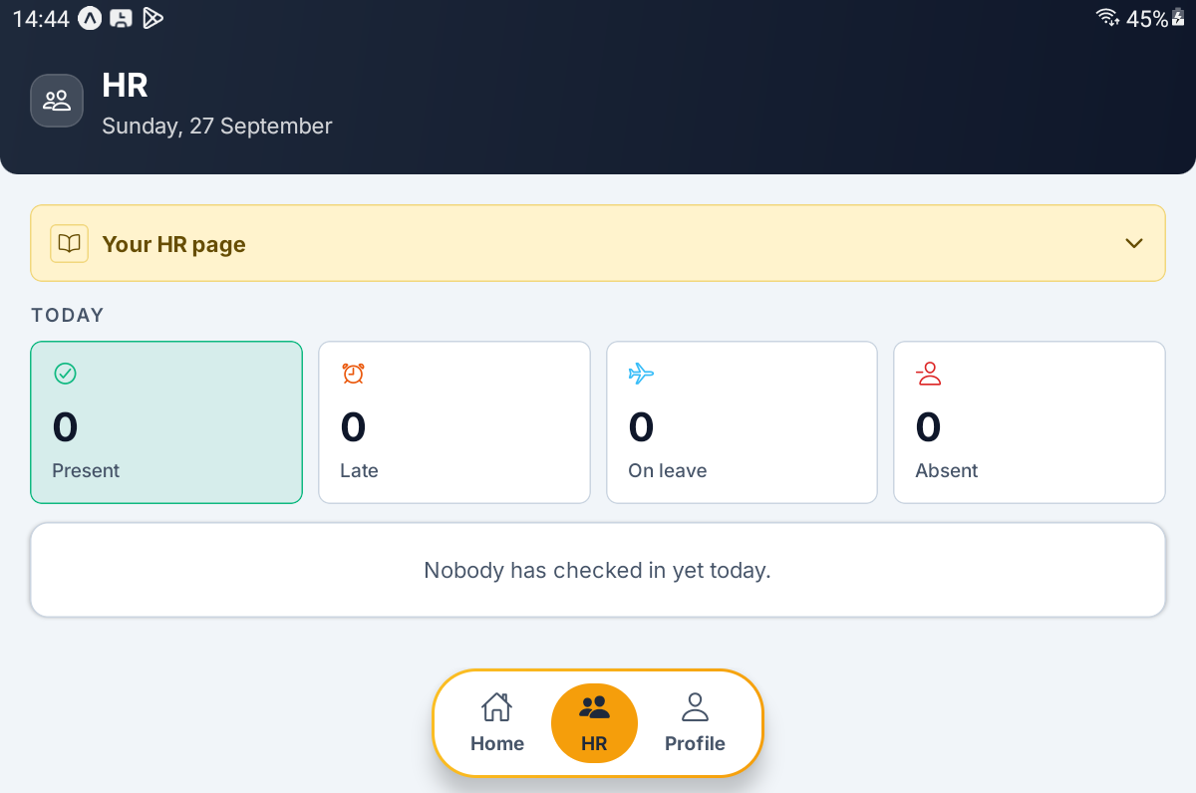
An HR Officer's page — TODAY only, with no approval rows

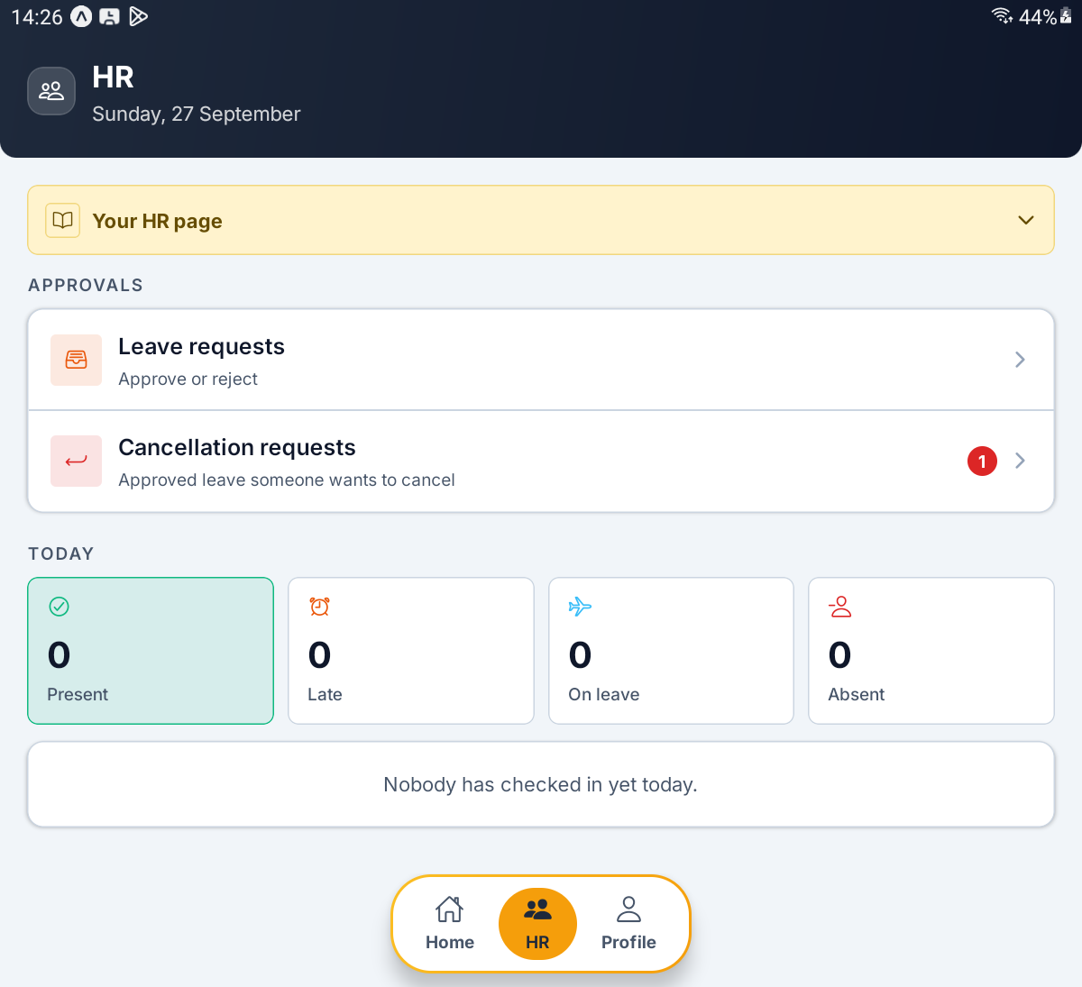
A Leave Manager without work-from-home rights — two approval rows and no Work from home requests

PART 2 LEAVE APPROVALS

Step 4 Open the Leave Queue
Tap Leave requests on the HR page. All Leave Requests opens, subtitled Everyone's requests, already on the Pending chip.
The chips in the header change what the list shows. Above the cards a line counts what you are looking at, for example 2 requests.
Chip | What it shows
Pending | Requests waiting for a decision — the ones you act on
Cancellation | Approved leave the employee has asked to cancel
All | Every request, whatever its state
Approved | Leave already granted
Rejected | Leave already turned down

With nothing waiting, Pending shows Nothing waiting and Every request has been decided. New ones appear here as they are submitted. Any other chip with nothing in it says Nothing matches that filter this time.
TIP The yellow How to approve leave box at the top is this step in four lines. Tap its heading to fold it away.

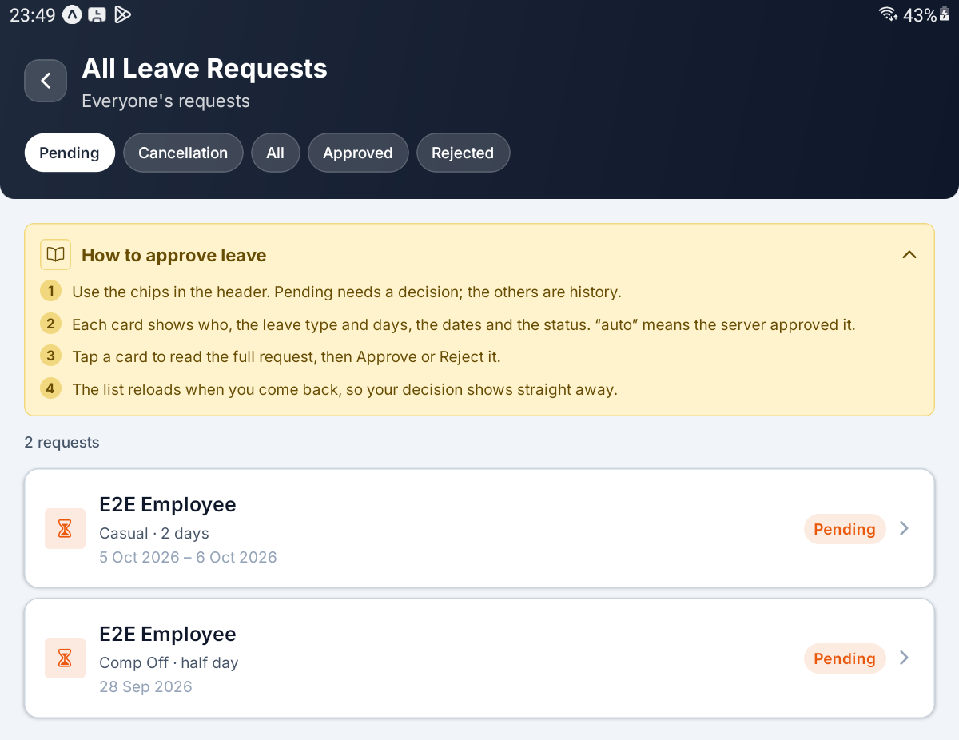
All Leave Requests on the Pending chip, with the How to approve leave guide and two waiting requests

Step 5 Read a Request Card
Each card is one request, sorted by the first day of leave with the latest at the top.
On the card | What it tells you
First line | The employee's name
Second line | The leave type and its length, for example Casual · 2 days or Comp Off · half day
Third line | The day, or the first and last day, for example 5 Oct 2026 – 6 Oct 2026
Status chip | Pending, Approved, Rejected, Cancelled or Draft
Cancel asked | The leave is approved, and the employee has asked for it to be cancelled
auto | Nobody decided it: the server approved it after it had waited as long as your administrator allows

The leave types are Sick, Casual, Annual, Personal, Emergency, Comp Off and Other.
Tap any card to open it. When you come back, the list reloads, so a decision you have just made shows straight away.
TIP Each chip lists the most recent 200 requests. On a busy site, older history may not appear under All.

Step 6 Open a Leave Request
The request opens with the employee's name as the title and Leave request beneath it. The yellow box is now How to decide this request.
The top card shows the leave type and its status chip, then the figures. Some rows appear only when they apply.
Row | What it tells you
Dates | The day, or the first and last day
Days | How many days, or Half day
Paid / unpaid | How many of those days are covered by paid leave, and how many are unpaid
Earned on | Comp Off only — the day or days the time off was earned
Comp-off balance | Comp Off only — what the employee has left. It turns red when it is less than the days asked for
Deduction | Shown in red, only when the unpaid days carry a pay deduction
Submitted | When the employee sent it
Approved by or Decided by | Who decided it, or Auto-approved. Not shown while the request is pending

Below the card, REASON shows what the employee wrote, or No reason given.
IMPORTANT Read Paid / unpaid before you approve. A figure such as 1 / 1 means one of the two days is not covered by paid leave. Whether an unpaid day costs pay depends on your leave policy; when it does, the Deduction row shows the amount.

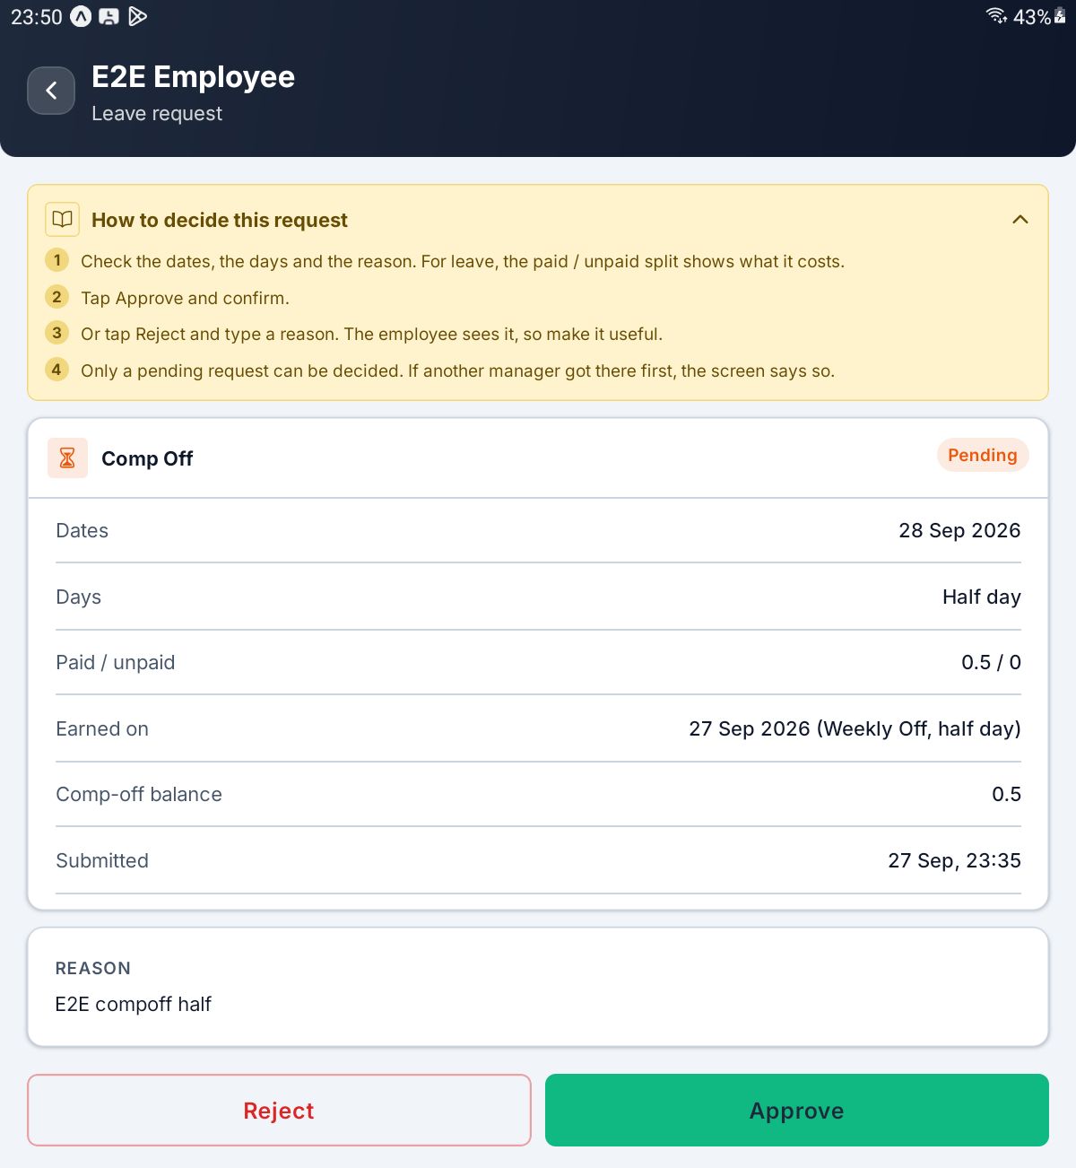
A Comp Off request — Earned on and Comp-off balance, with Reject and Approve beneath

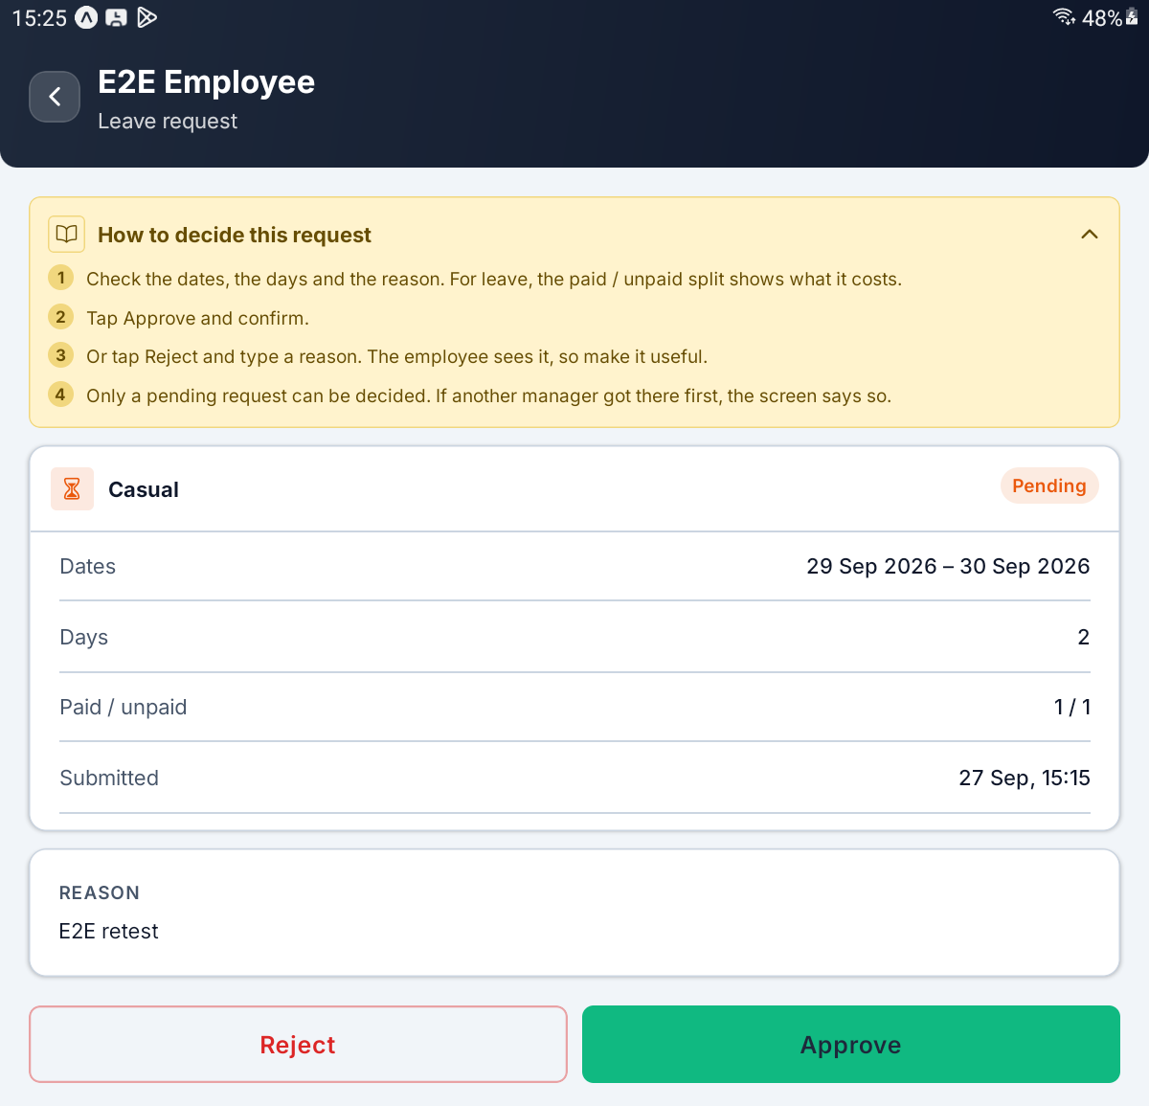
A two-day Casual request where one day is unpaid — Paid / unpaid reads 1 / 1

Step 7 Approve a Leave Request
Tap Approve. A window asks Approve this request? and explains that the employee will be marked on leave, and those days leave the attendance grading. Tap Approve again to confirm, or Cancel to go back.
On success you see Request approved. and are returned to the queue, where the request has already left Pending.
What you tap | What happens
Approve on the request | Opens the confirmation
Approve in the window | Grants the leave; the employee sees it as approved
Cancel | Closes the window; nothing changes

If the server refuses, its own reason appears in a red message and the request stays open, reloaded to show its latest state. Two common causes are a Comp Off request with too little balance left to cover it, and a request that somebody else has just decided.
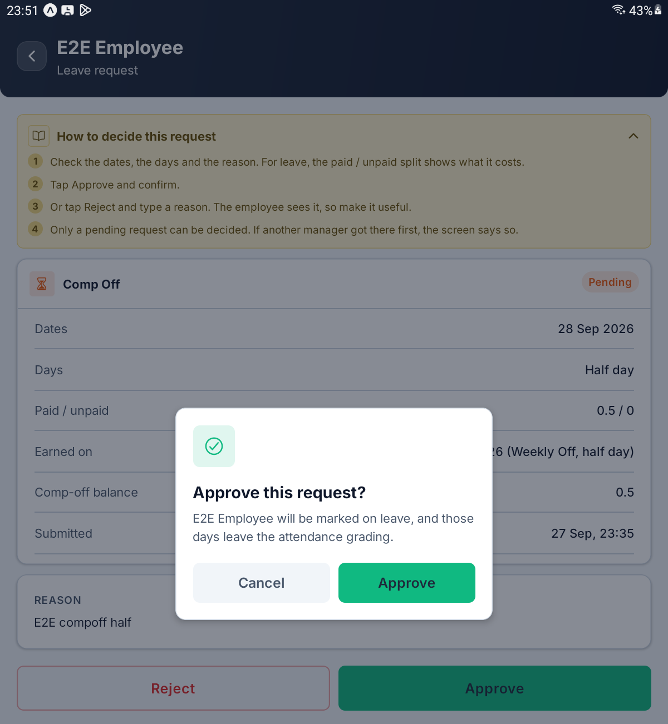
The Approve this request? window on a Comp Off request

Step 8 Reject a Leave Request
Tap Reject. The window asks Reject this request? and reminds you that The employee sees this reason, so make it useful. Type into Reason for rejection, then tap Reject.
A reason is required. Tap Reject with the box empty and it turns red with Give a reason — the employee sees this. Nothing is sent until you type something. While the app is sending, the button reads Working….
On success you see Request rejected. The reason stays on the request and appears under REJECTED BECAUSE whenever it is opened again.
What you tap | What happens
Reject on the request | Opens the reason window
Reason for rejection | Type what the employee will read
Reject in the window | Turns the request down and records you as the person who decided it
Cancel | Closes the window and throws away what you typed

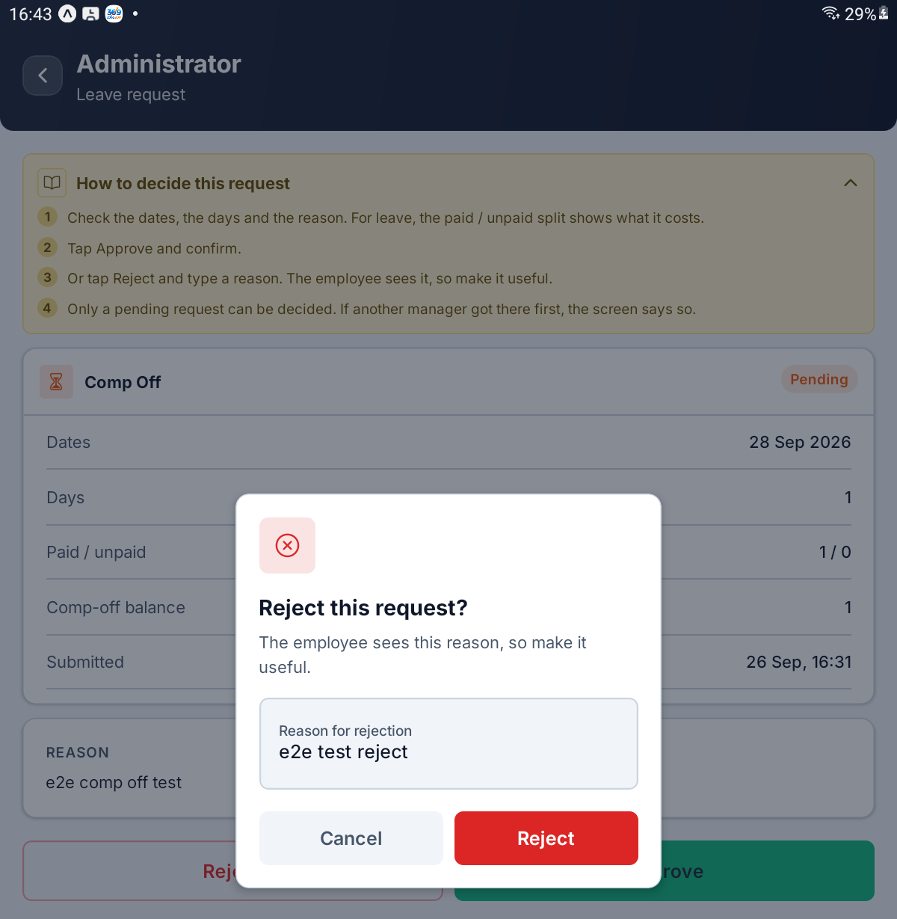
The Reject this request? window with a reason typed in

Step 9 Know What Cannot Be Changed
Only a pending request can be decided. Open a rejected or cancelled request and the buttons are replaced by a single line, such as Already rejected — only a pending request can be decided.
There is no way to undo a rejection or to change its reason afterwards. If a rejection was a mistake, the employee applies again. Approved leave is the one exception: it can still be cancelled, as PART 3 explains, and it shows a Cancel this leave button instead of the line.
If two of you open the same request and the other person decides first, your tap is refused with Only pending requests can be approved. or Only pending requests can be rejected., and the screen reloads to show what they decided. The same happens if the server approved the request automatically while you were reading it.
What you see | What it means
Already rejected — only a pending request can be decided. | Turned down; it stays that way
Already cancelled — only a pending request can be decided. | Withdrawn or cancelled; it stays that way
REJECTED BECAUSE | The reason given when it was rejected
That request no longer exists. | The request could not be found. Go back and pull the list down to refresh it
The server refused that. | The server said no without giving a reason. Try again, and ask your administrator if it keeps happening

[ IMAGE 10 — not captured yet ]
A rejected request — the REJECTED BECAUSE box and the line saying only a pending request can be decided

PART 3 CANCELLATION REQUESTS

Step 10 Open the Cancellation Queue
An employee cannot cancel leave that has already been approved. Instead they ask HR, with a reason, and those requests collect under Cancellation requests on the HR page.
Tapping it opens All Leave Requests on the Cancellation chip. Each card shows the leave as Approved, with an orange Cancel asked chip beneath.
Nothing has changed yet. The leave stays approved, and keeps counting as leave, until you decide.
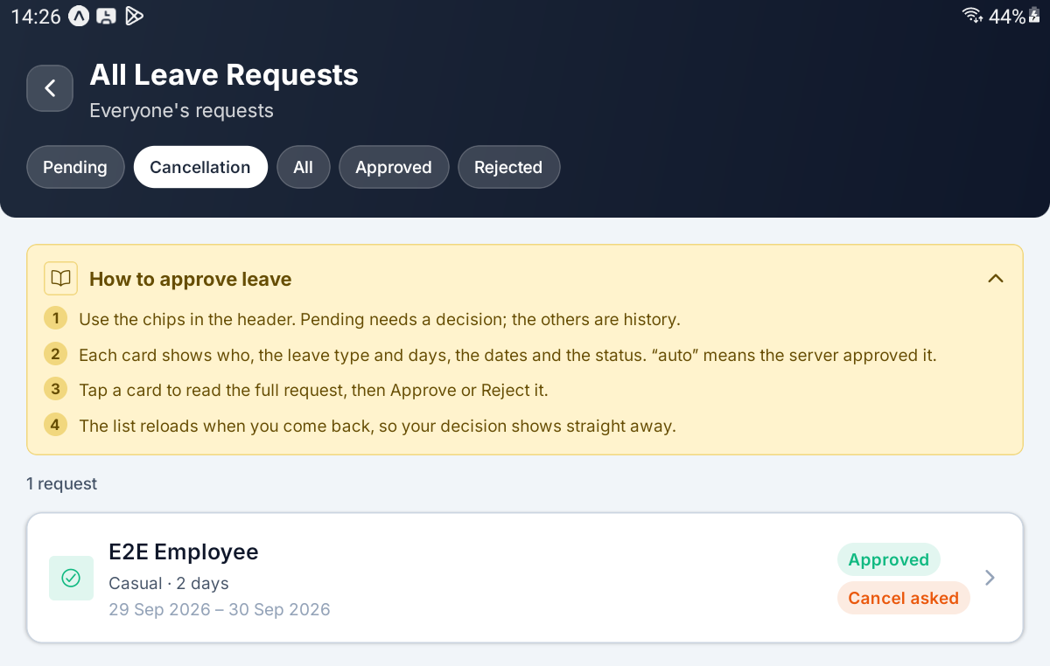
The Cancellation chip — an approved leave carrying the Cancel asked chip

Step 11 Read the Cancellation Request
Open the card. The yellow box now reads How to decide a cancellation. Below the usual figures and REASON sits an orange box headed CANCELLATION REQUESTED, with the employee's reason for cancelling and when they asked, for example Asked 27 Sep, 15:25.
REASON is why they wanted the leave in the first place. CANCELLATION REQUESTED is why they no longer want it.
What you tap | What happens
Approve cancellation | Cancels the leave and gives the days back to the balance
Keep leave | Leaves it approved; you must say why

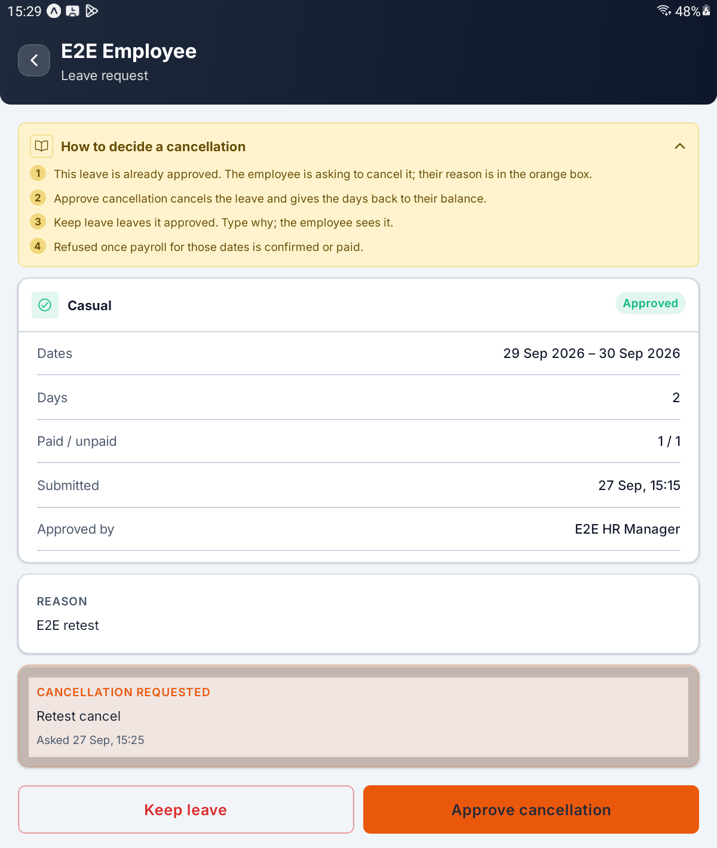
A cancellation request — the orange CANCELLATION REQUESTED box, with Keep leave and Approve cancellation

Step 12 Approve the Cancellation
Tap Approve cancellation. The window asks Approve the cancellation? and explains that the leave is cancelled and its days go back to the balance, then warns: Refused if that month's payroll is already confirmed or paid. Tap Approve, or Back to leave it as it is.
On success you see Leave cancelled. The leave now shows Cancelled, and it leaves the Cancellation chip. When the last one is dealt with, the chip reads No cancellation requests.
IMPORTANT Once the payroll run covering any day of the leave has been confirmed or paid, the server refuses with a message such as Payroll for September 2026 is already confirmed, so this leave can no longer be cancelled. Reopen the payroll run first. Payroll is not on the HR tab. Ask your administrator to reopen the run, then try again.

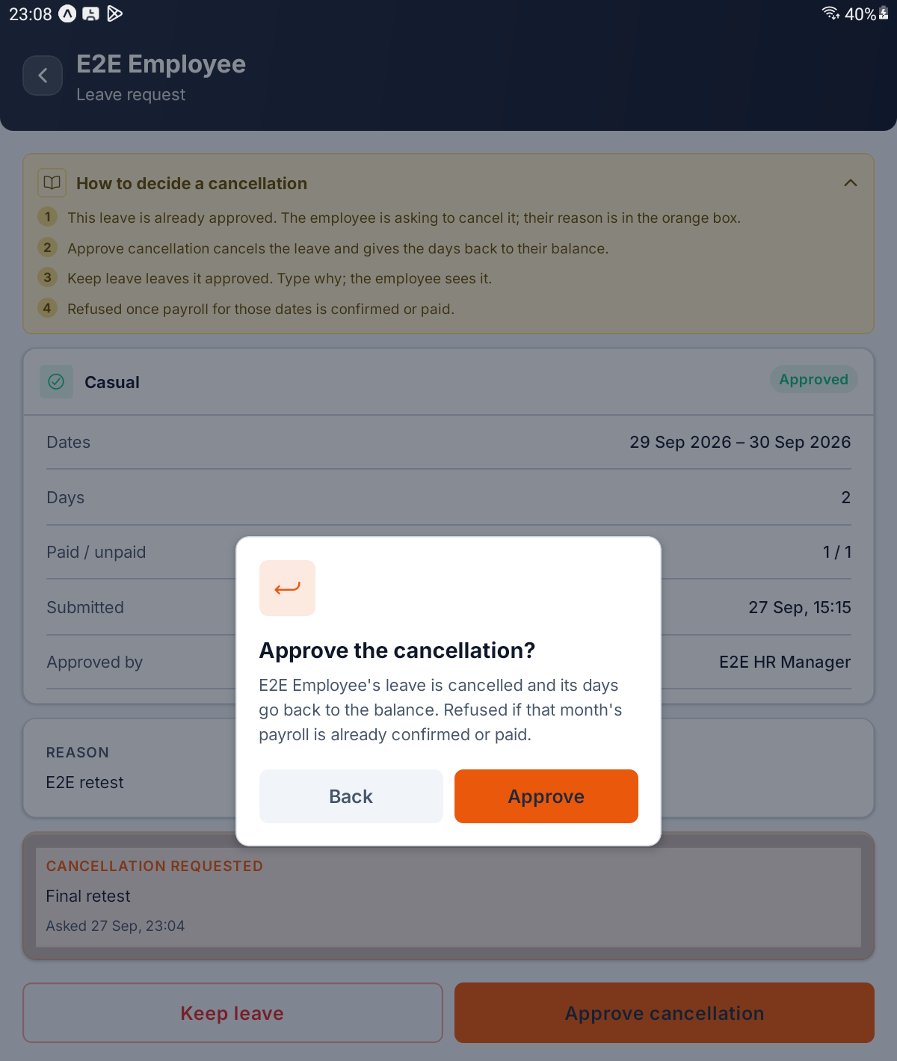
The Approve the cancellation? window, with its payroll warning

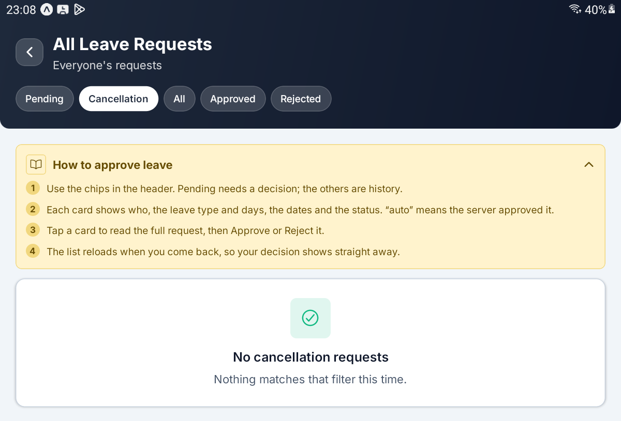
The Cancellation chip once every request has been decided

Step 13 Keep the Leave
Tap Keep leave. The window asks Keep this leave? and explains The leave stays approved. The employee sees your reason. Type into Why it stays, then tap Keep leave.
The reason is required. An empty box turns red with Give a reason — the employee sees this.
On success you see Cancellation declined; leave kept. The Cancel asked chip disappears and the leave carries on as approved. If the employee's plans change again, they can send a fresh cancellation request.
What you tap | What happens
Why it stays | Type what the employee will read
Keep leave in the window | Declines the cancellation; the leave stays approved
Cancel | Closes the window; the request is still waiting

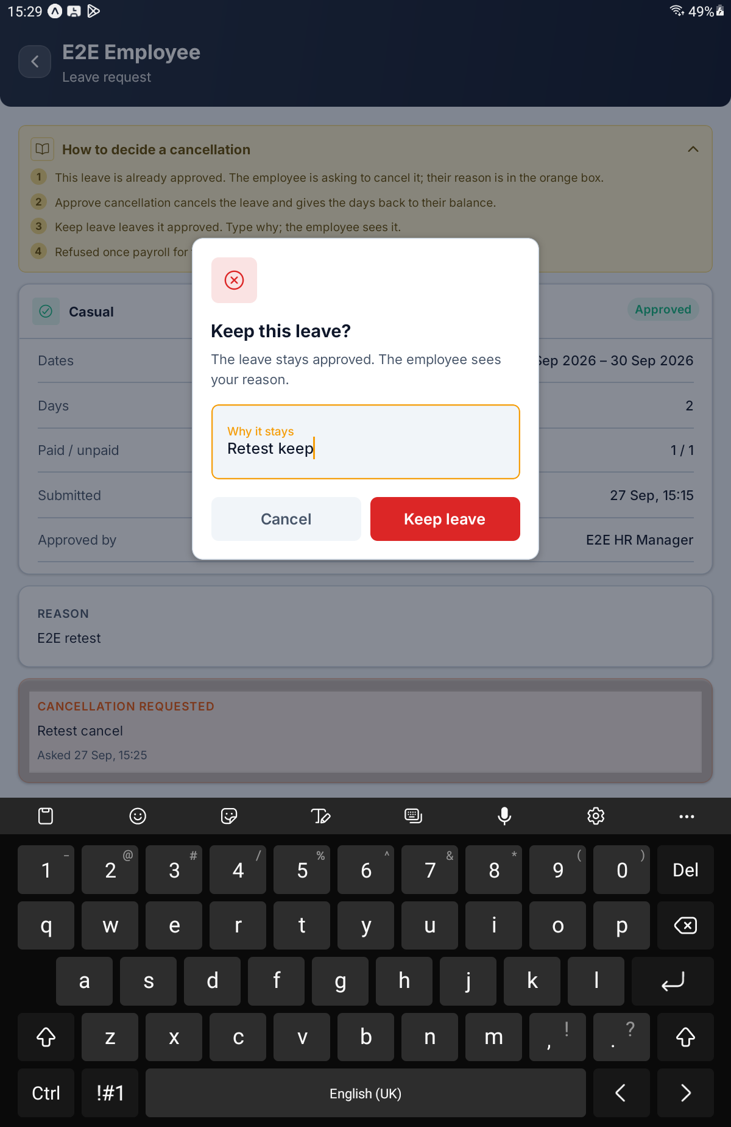
The Keep this leave? window with the reason typed in

Step 14 Cancel Approved Leave Yourself
You do not have to wait for the employee to ask. Open any approved leave that has no cancellation request on it, from the Approved or All chip, and a single Cancel this leave button sits at the bottom.
Tapping it asks Cancel this approved leave?, with the same payroll warning. Tap Cancel leave to go ahead, or Back to keep it. The result is the same as approving a cancellation: Leave cancelled., and the days go back to the balance.
This window asks for no reason, so tell the employee yourself why their leave was cancelled.
What you tap | What happens
Cancel this leave | Opens the confirmation
Cancel leave | Cancels the approved leave
Back | Closes the window; the leave stays approved

[ IMAGE 16 — not captured yet ]
An approved leave with the Cancel this leave button, and the Cancel this approved leave? window

PART 4 WORK FROM HOME APPROVALS

Step 15 Open the Work From Home Queue
Tap Work from home requests on the HR page. All WFH Requests opens on the Pending chip, with the yellow box How to approve work from home.
Each card shows the employee, Work from home and the day asked for. There is no Cancellation chip here: an employee who no longer needs an approved day cancels it themselves.
Chip | What it shows
Pending | Days waiting for a decision
All | Every request, whatever its state
Approved | Granted, and not yet checked in
Done | The employee checked in and out on the day
Rejected | Turned down

Under All you may also see Checked in (working from home right now), Cancelled (withdrawn by the employee) and Expired (approved, but the day passed without a check-in).
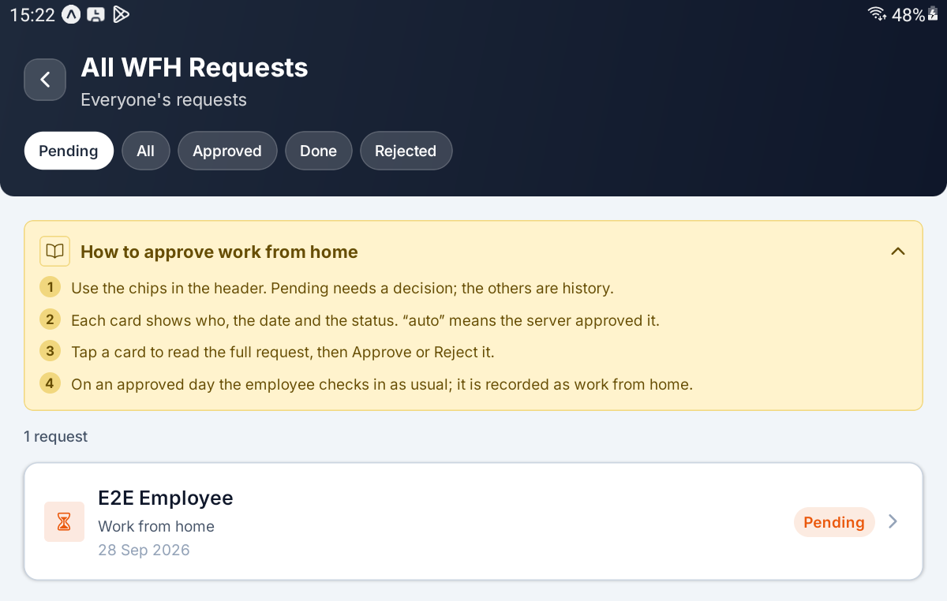
All WFH Requests on the Pending chip, with one waiting request

Step 16 Decide a Work From Home Request
Tap a card. The request opens with Work from home under the employee's name and shows Date and Submitted, then Approved by or Decided by once it has been decided. After the employee has checked in, a Worked row adds the check-in time and the hours worked. REASON is underneath.
Tap Approve and the window says the employee will be able to check in from home on that day. Tap Approve to confirm.
Tap Reject and you get the same Reject this request? window as for leave. A reason is required here too, and the server refuses an empty one on its own account with Rejection reason is required.
On the day, the employee checks in as usual and it is recorded as work from home. On the TODAY list they carry a WFH chip.
IMPORTANT An approved work-from-home day cannot be withdrawn from the HR tab. Opening it shows Already approved — only a pending request can be decided. Only the employee can cancel it.

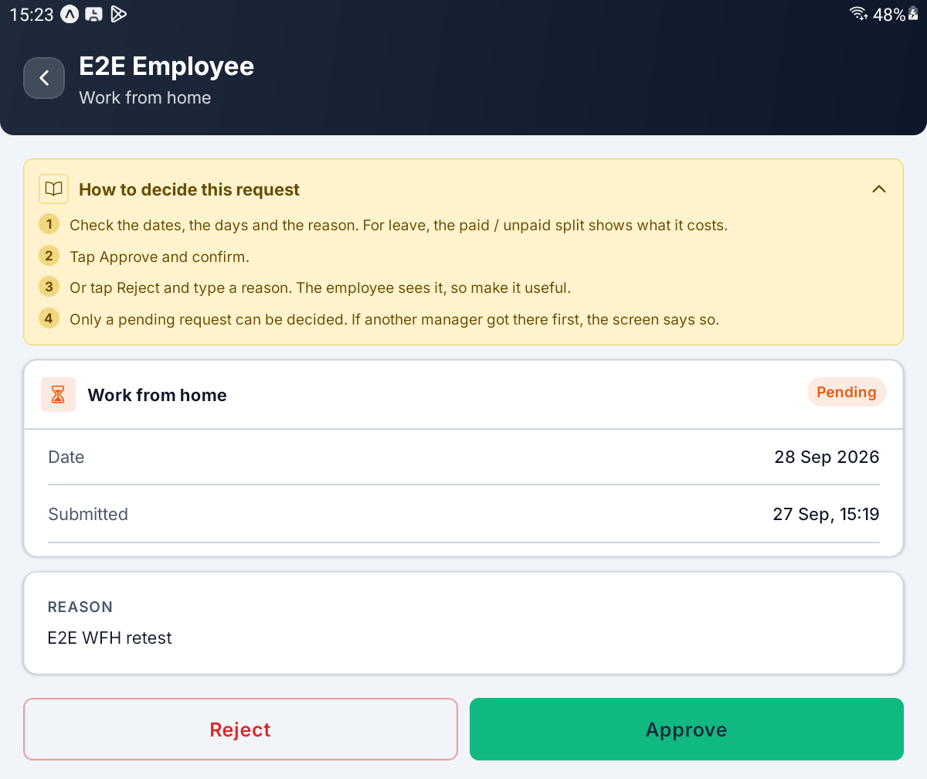
A pending work-from-home request — Date, Submitted and REASON, with Reject and Approve

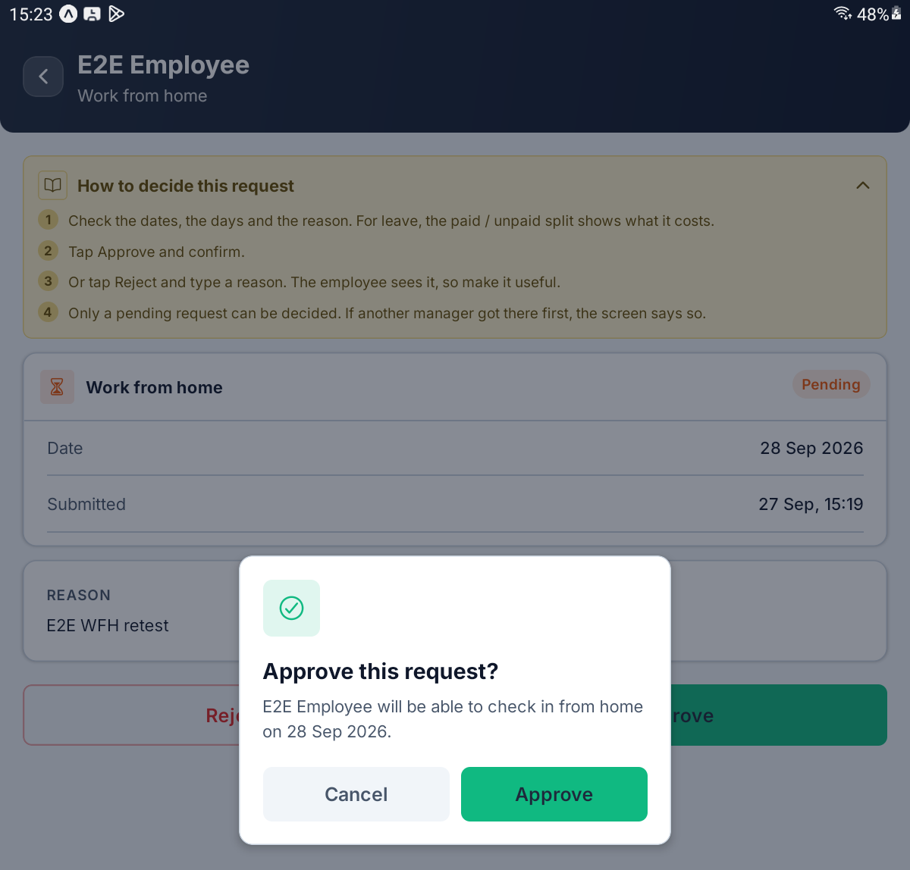
The Approve this request? window for a work-from-home day

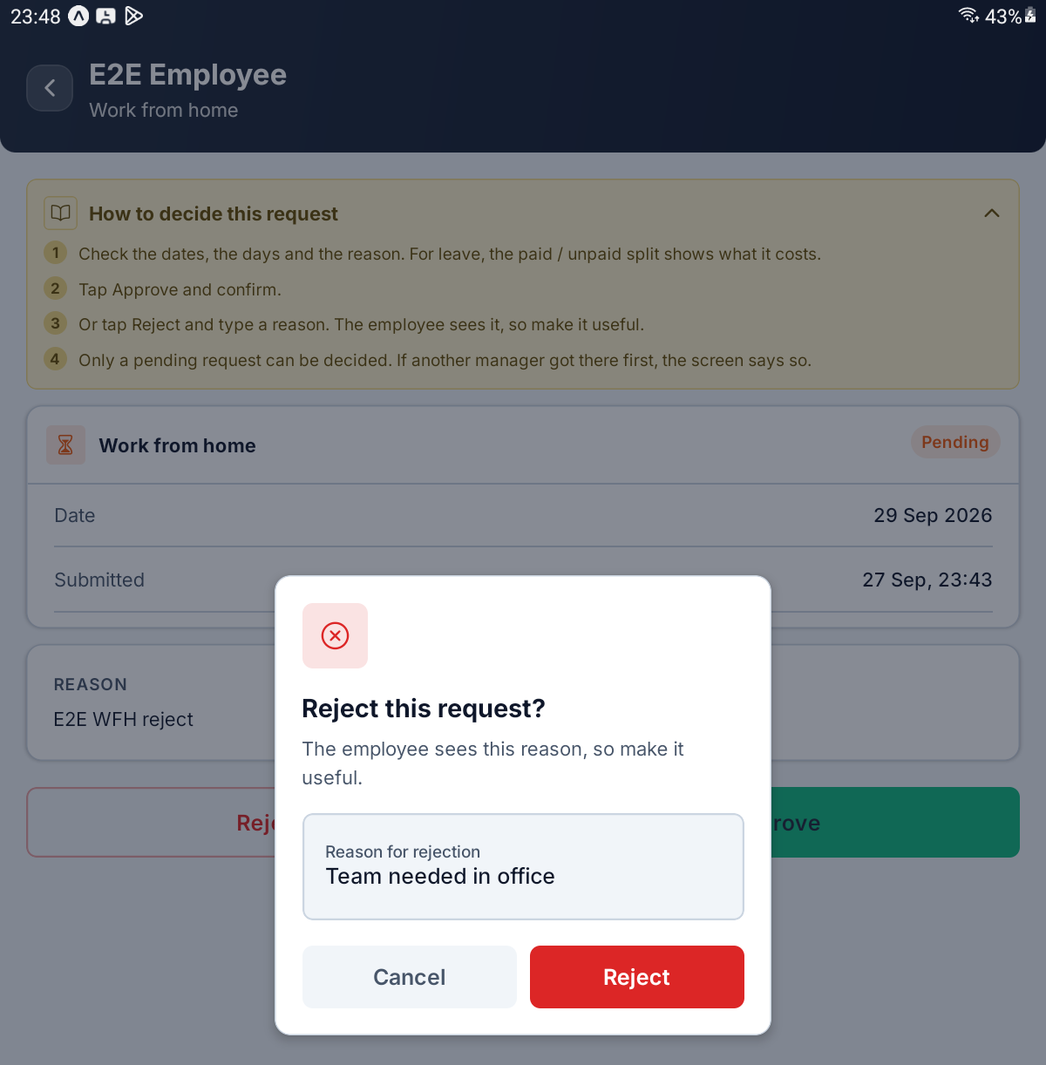
Rejecting a work-from-home day with a reason typed in

PART 5 TODAY AT A GLANCE

Step 17 See Who Is In Today
The TODAY section needs the HR Officer or HR Manager permission. It shows four boxes, each with a count, and a list of names beneath the box that is selected. Present is selected when the page opens.
Tap a box to list the people in it. The list appears right there on the HR page; tapping a name does not open anything further.
Box | Who it counts
Present | Everyone who turned up today, including those who were late or are on a half day
Late | Those who checked in after the grace time
On leave | Those covered by approved leave today
Absent | Those the server has marked absent

Each row shows the person's name, today's date and a status chip: Present, Late, Half Day, Leave or Absent. A WFH chip means they are working from home, an On leave chip means approved leave covers the day, and auto-stamped means the server marked the day itself. No pay figures are shown here.
If the box is empty you see | Why
Nobody has checked in yet today. | Nobody is in yet
Nobody is late today. | Everyone so far was on time
Nobody is on leave today. | No approved leave covers today
Nobody is marked absent yet. Absent appears once the late window ends. | It is too early for anyone to be marked absent

[ IMAGE 21 — not captured yet ]
TODAY with the Present box selected and the names listed beneath it

Step 18 Know When Absent Fills In
A person gets a row for today once they check in, once approved leave covers the day, or once the server marks them absent. That last step happens only after the late window your administrator has set, so early in the morning Absent is normally empty.
Absent is therefore not a live list of who has not arrived yet. Before the late window ends, someone missing is simply not on any list.
If someone shows as Absent and you know they have leave waiting, check the Pending chip on Leave requests. Approving leave for a day already marked absent moves them to leave.
Someone working on their weekly off or on a public holiday is not counted in any of the four boxes.
TIP The HR tab shows today only. Past days, late records and monthly reports are on your administrator's screens, not here.

QUICK REFERENCE

Where Things Live
To do this | Go here
Approve or reject leave | HR → Leave requests → open the card → Approve or Reject
Decide a cancellation | HR → Cancellation requests → Approve cancellation or Keep leave
Cancel approved leave yourself | Leave requests → Approved → open it → Cancel this leave
Look back at decided leave | Leave requests → All, Approved or Rejected
Approve or reject work from home | HR → Work from home requests → open the card
See who is in today | HR → TODAY → tap a box
See who is absent | HR → TODAY → Absent
Refresh the counts | Pull the HR page down
Your own check-in, leave and work from home | Home

Things to Remember
▪ Only a pending request can be decided. A rejection is final; approved leave can only be cancelled.
▪ A reason is required to reject, and to keep leave. The employee reads it, so make it useful.
▪ Read Paid / unpaid before you approve. It shows how much of the leave is unpaid.
▪ Leave rights and work-from-home rights are separate. Holding one does not give you the other.
▪ Cancelling approved leave stops at payroll. Once that month's payroll is confirmed or paid, the server refuses until your administrator reopens the run.
▪ Cancel this leave asks for no reason. Tell the employee yourself.
▪ auto means nobody decided it. The server approved it after the wait your administrator set.
▪ Someone else may get there first. If the server refuses, the screen reloads to show the decision already made.
▪ An approved work-from-home day is the employee's to cancel, not yours.
▪ Absent fills in after the late window ends. An empty Absent box early in the morning is normal.
▪ Permission changes need a fresh sign-in. Sign out and back in after your administrator changes your rights.
▪ Rules, holidays, leave policy and payroll are not on the HR tab. Ask your administrator.
Open the request, read the figures, and decide it with a reason the employee can use. That is the whole of the HR tab.

— End of Guide —
Alphalize Technologies | 369 Attendance HR Guide

